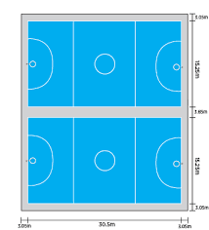

**Netball court numbers at Hope Academy**

Muga 2

Muga 1

Court 6

Court 5

Court 4

Court 3

Court 2

Court 1