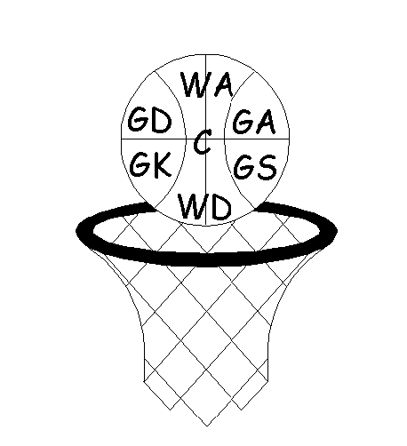

Summer 2022 Venue: Hope Academy, Ashton Rd, Newton WA12 0AQ

- The Umpiring/Scorer rota is: Play at: 7:00 Umpire/Score at 8:00
Play at: 8:00 Umpire/Score at 7:00

- Captains shall toss for centre pass/choice of ends prior to match starting time
- Player movement rules apply. Ie: only 2 players can play down one team. Can only play one match per night
- Each team to pay the umpire £10.00 prior to the commencement of the match
- Duration of the matches shall be 4 x 12 minutes - with 2 minute at intervals. Central timing start and end all quarters
- Central timing start and end all quarters
- All Teams must provide an umpire and scorer
- Home teams responsible for completing the match card and attachment of both score cards
- All match cards should be completed in FULL – date, division, teams, score, umpires, scorers and POM & put in the box provided. All names should be printed, first & last names (no initials) AENA ID’s
- All teams should refresh themselves with the bylaws of the league (ie: what happens if teams are late, Code of conduct, player movement etc etc)
- The winning team must text the score and details to the number - 07795 257837 in the following format
WDNL Summer: 20/7/22: Div 1: Halton 2 54-54 B’Wood 1: Bev, Halton (match winners team first)

Premier Division

Time Court 20/04/22 Time Court 27/04/22 Time Court 04/05/22
7:00 1 1 v 5 7:00 1 5 v 4 7:00 1 6 v 8
7:00 2 3 v 8 7:00 2 6 v 7 7:00 2 2 v 4
8.00 1 7 v 4 8.00 1 8 v 1 8.00 1 5 v 7
8.00 2 2 v 6 8.00 2 2 v 3 8.00 2 3 v 1

Time Court 11/05/22 Time Court 18/05/22 Time Court 25/05/22
7:00 1 6 v 5 7:00 1 5 v 2 7:00 1 3 v 5
7:00 2 2 v 8 7:00 2 6 v 3 7:00 2 7 v 2
8.00 1 3 v 4 8.00 1 8 v 7 8.00 1 4 v 8
8.00 2 7 v 1 8.00 2 4 v 1 8.00 2 1 v 6

Time Court 08/06/22 Time Court 15/06/22 Time Court 22/06/22
7:00 1 4 v 6 7:00 1 5 v 1 7:00 1 4 v 5
7:00 2 1 v 2 7:00 2 8 v 3 7:00 2 7 v 6
8.00 1 5 v 8 8.00 1 4 v 7 8.00 1 1 v 8
8.00 2 7 v 3 8.00 2 6 v 2 8.00 2 3 v 2

Time Court 29/06/22 Time Court 06/07/22 Time Court 13/07/22
7:00 1 6 v 8 7:00 1 5 v 6 7:00 1 2 v 5
7:00 2 4 v 2 7:00 2 8 v 2 7:00 2 3 v 6
8.00 1 7 v 5 8.00 1 4 v 3 8.00 1 7 v 8
8.00 2 1 v 3 8.00 2 1 v 7 8.00 2 4 v 1

Time Court 20/07/22 Time Court 27/07/22
7:00 1 5 v 3 7.00 1 6 v 4
7.00 2 2 v 7 7.00 2 1 v 2
8.00 1 8 v 4 8.00 1 8 v 5
8.00 2 6 v 1 8.00 2 3 v 7

- Warrington 1 5. Panthers
- Capricorn 1 6. Greenbank
- Halton 1 7. Beechwood 2
- Knutsford 1 8. Imagine8

