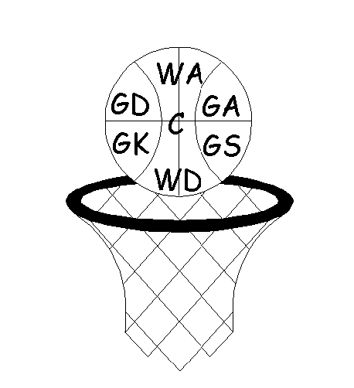
Warrington & District Netball League
Winter Season 2021-22
Premier & Division 1

Venue: Birchwood Tennis & Leisure Complex, Benson Rd

- The Umpiring/Scorer rota is: play at: 7:05 Umpire/Score at 8:10
play at: 8:10 Umpire/Score at 9:15
play at: 9.15 Umpire/Score at 7.05
- Captains shall toss for centre pass/choice of ends prior to match starting time
- Player movement rules apply. Ie: only 2 players can play down one team. Only play one match per night
- Each team to pay the umpire £10.00 prior to the commencement of the match
- Duration of the matches shall be 4 x 15 minutes - with 1 minute for all intervals. Two minutes between games. Central timing to start and end all quarters and the match
- All Teams must provide a scorer
- All match cards should be completed in FULL – date, division, teams, score, umpires, scorers and POM & put in the box provided. All names should be complete -first & last names (no initials) Please print so names are eligible
- The winning team must text the score and the winner in format given to Paul - 07795 257837 I.E. WDNL SUMMER/DATE/DIVISION/WINNING TEAM NAME FIRST WITH SCORE THEN LOSING TEAM THEN YOUR NAME AND CLUB

Time Court 13/10/21 Time Court 20/10/21 Time Court 27/10/21
7:05 1 1 v 2 7:05 1 3 v 4 7:05 1 5 v 7
7.05 2 7 v 8 7.05 2 9 v 10 7.05 2 1 v 3
8:10 1 3 v 4 8:10 1 5 v 6 8:10 1 6 v 9
8.10 2 9 v 10 8.10 2 1 v 3 8.10 2 2 v 4
9:15 1 5 v 6 9:15 1 7 v 8 9:15 1 8 v 10
9.15 2 1 v 2 9.15 2 2 v 4 9.15 2 5 v 7

Time Court 3/11/21 Time Court 10/11/21 Time Court 17/11/21
7:05 1 6 v 9 7:05 1 7 v 9 7:05 1 5 v 8
7.05 2 2 v 3 8.10 1 1 v 4 8.10 1 6 v 10
8:10 1 8 v 10 9:15 1 2 v 3 9:15 1 7 v 9
8.10 2 5 v 8 8.10
9:15 1 1 v 4 9.15 ONLY COURT 1 AVAILABLE
9.15 2 6 v 10 9.15

Time Court 24/11/21 Time Court 1/12/21 Time Court 8/12/19
7:05 1 1 v 5 7:05 1 2 v 6 7:05 1 3 v 8
7.05 2 4 v 10 7.05 2 8 v 9 7.05 2 1 v 6
8:10 1 2 v 6 8:10 1 3 v 7 8:10 1 4 v 7
8.10 2 8 v 9 8.10 2 1 v 6 8.10 2 2 v 10
9:15 1 3 v 7 9:15 1 4 v 10 9:15 1 9 v 5
9.15 2 1 v 5 9.15 2 2 v 10 9.15 2 3 v 8

Time Court 15/12/21 Time Court 5/1/22 Time Court 12/1/22
7:05 1 4 v 7 7:05 1 5 v 10 7:05 1 1 v 10
7.05 2 2 v 8 7.05 2 3 v 9 7.05 2 4 v 8
8:10 1 5 v 9 8:10 1 1 v 7 8:10 1 2 v 9
8.10 2 3 v 9 8.10 2 4 v 6 8.10 2 6 v 7
9:15 1 1 v 7 9:15 1 2 v 8 9:15 1 3 v 5
9.15 2 4 v 6 9.15 2 5 v 10 9.15 2 1 v 10

Time Court 19/1/22 Time Court 26/1/22 Time Court 2/2/22
7:05 1 2 v 9 7:05 1 3 v 6 7.05 1 4 v 9
7.05 2 6 v 7 7.05 2 1 v 8 7.05 2 1 v 9
8:10 1 3 v 5 8:10 1 4 v 9 8.10 1 7 v 10
8.10 2 1 v 8 8.10 2 2 v 5 8.10 2 2 v 7
9:15 1 4 v 8 9:15 1 7 v 10 9.15 1 6 v 8
9.15 2 2 v 5 9.15 2 3 v 6 9.15 2 3 v 10

Time Court 9/2/22
7:05 1 4 v 5
7.05 2 2 v 7
8:10 1 6 v 8
8:10 2 3 v 10
9.15 1 1 v 9
9.15 2 4 v 5

PREM TEAMS DIVISION 1 TEAMS

- Beechwood 2 1. Beechwood 1
- Capricorn 1 2. Capricorn 2
- Halton 1 3. Halton 2
- Imagine8 4. Saints 2
- Knutsford 1 5. Knutsford 3
- Warrington 2 6. Warrington 5
- Panthers 7. Beechwood 3
- Saints 1 8. Saints 3
- Knutsford 2 9. Knutsford 4
- Warrington 3 10. Saints 4

